# Assignment-3

Python Programming

|  |  |
| --- | --- |
| Assignment Date | 11 October 2022 |
| Student Name | Saravanan B |
| Student Roll Number | 9517201904138 |
| Maximum Marks | 2 Marks |

# Question-1:

Write a python code for led blinking in raspberry pi

**Solution:**

import RPi.GPIO as GPIO

from time import sleep

GPIO.setmode(GPIO.BOARD)

GPIO.setup(7, GPIO.OUT)

while True:

GPIO.output(7, GPIO.HIGH)

print(“LED On”)

sleep(1)

GPIO.output(7, GPIO.LOW)

sleep(1)

print(“LED Off”)

**Output:**

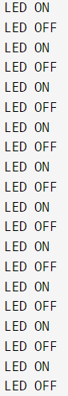

# Question-2:

Write a python code for traffic light in raspberry pi

**Solution:**

from gpiozero import TrafficLights

from time import sleep

lights = TrafficLights(10, 9, 11)

while True:

light.red.off()

light.green.on()

print(GREEN)

sleep(1)

light.green.off()

lights.amber.on()

print(AMBER)

sleep(1)

lights.amber.off()

light.red.on()

print(RED)

sleep(1)

**Output:**

